**­­CIE Computer Science /41**

**Chapter 5 – The Internet and its uses test**

Q1

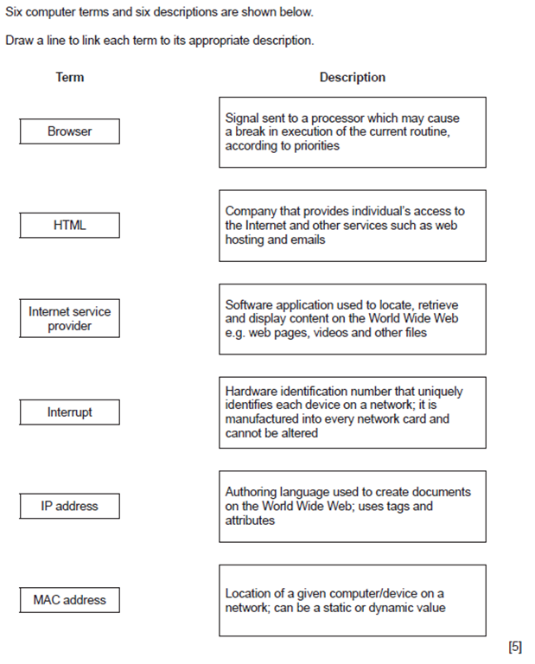

Q2

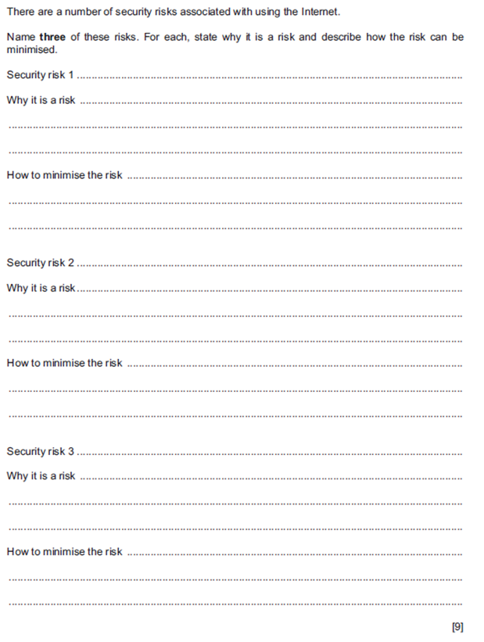

Q3

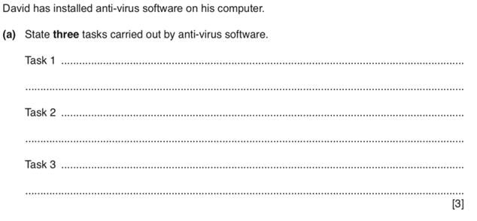

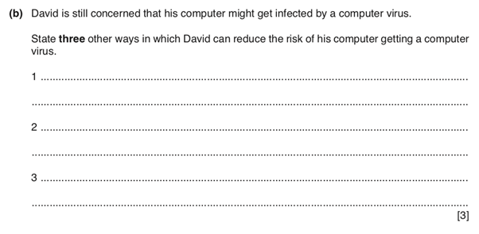

**Q4) Explain each of the following terms:**

1. **Hacker**

**………………………………………………………………………………………………**

**………………………………………………………………………………………………[2]**

1. **Malware**

**……………………………………………………………………………………………**

**………………………………………………………………………………………………[2]**

1. **Virus**

**………………………………………………………………………………………………**

**………………………………………………………………………………………………[2]**

1. **Spyware**

**………………………………………………………………………………………………**

**………………………………………………………………………………………………[2]**

**5). Explain the difference between a dynamic IP address and a static IP address**

**………………………………………………………………………………………………**

**………………………………………………………………………………………………**

**………………………………………………………………………………………………**

**………………………………………………………………………………………………**

**………………………………………………………………………………………………**

**………………………………………………………………………………………………**

**……………………………………………………………………………………………[3]**

**6)**



