Name_________________________________  **/51**

**CIE Computer Science**

**CHAPTER 3 – Hardware**

1)

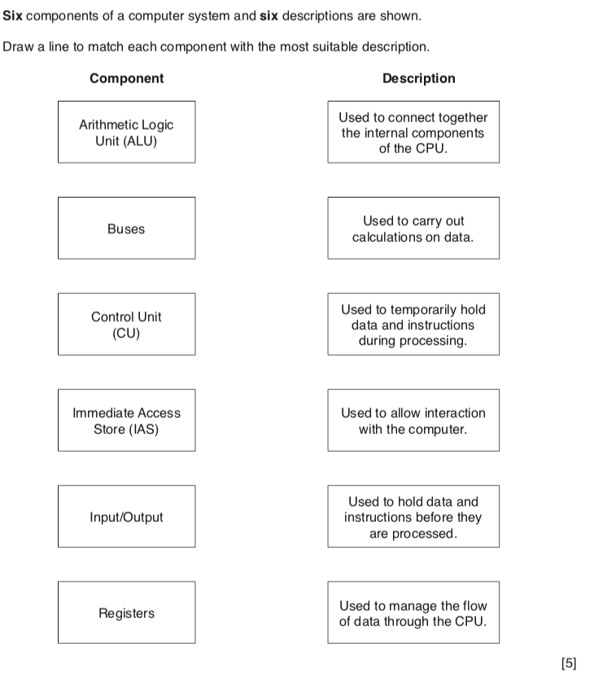

2)

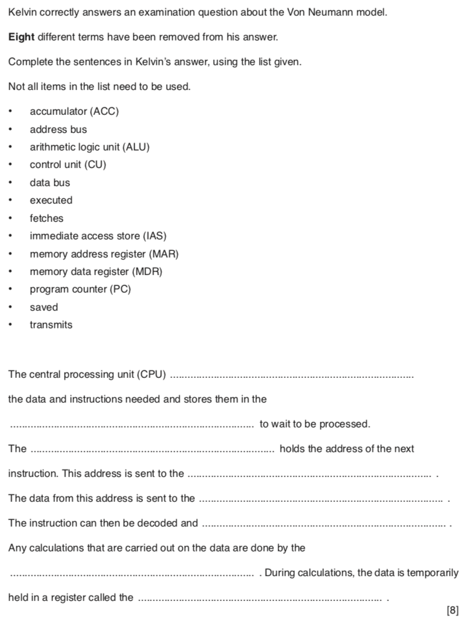

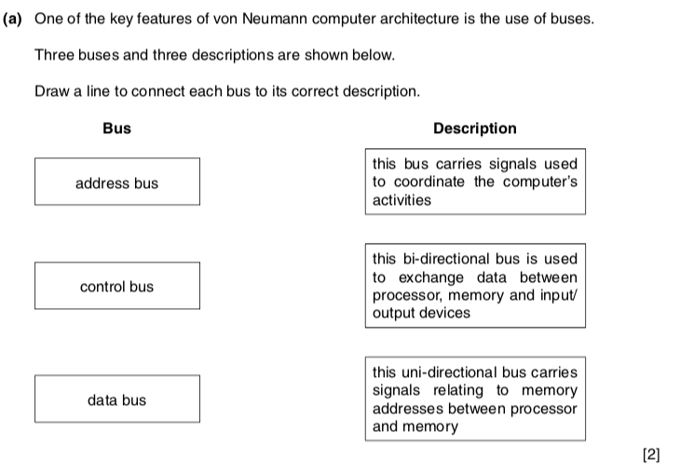3)

4)

a)

The Fetch - Decode - Execute cycle takes place in 3 steps. The first step is **Fetching the instruction.** Explain the first step using the words:

* **CPU**
* **Address bus**
* **Register**

**……………………………………………………………………………………………………………**

**……………………………………………………………………………………………………………**

**……………………………………………………………………………………………………………**

**………………………………………………………………………………………………………….[4]**

b**)** Step 2 is **Decoding the instruction,** explain this step using the words:

* **CPU**
* **CU**
* **Instruction Set**

**……………………………………………………………………………………………………………**

**……………………………………………………………………………………………………………**

**……………………………………………………………………………………………………………**

**………………………………………………………………………………………………………….[4]**

c) Step 3 is **Executing the instruction,** explain this step using the words:

* **CPU**
* **ALU**

**……………………………………………………………………………………………………………**

**……………………………………………………………………………………………………………**

**……………………………………………………………………………………………………………**

**………………………………………………………………………………………………………….[3]**

**5)**

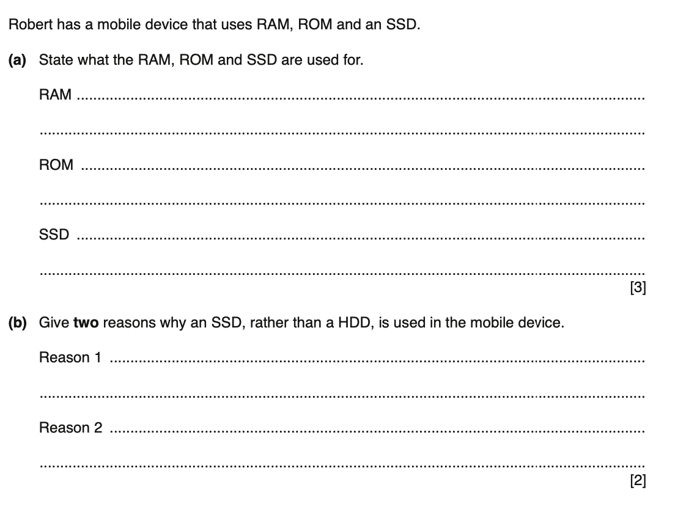

6)

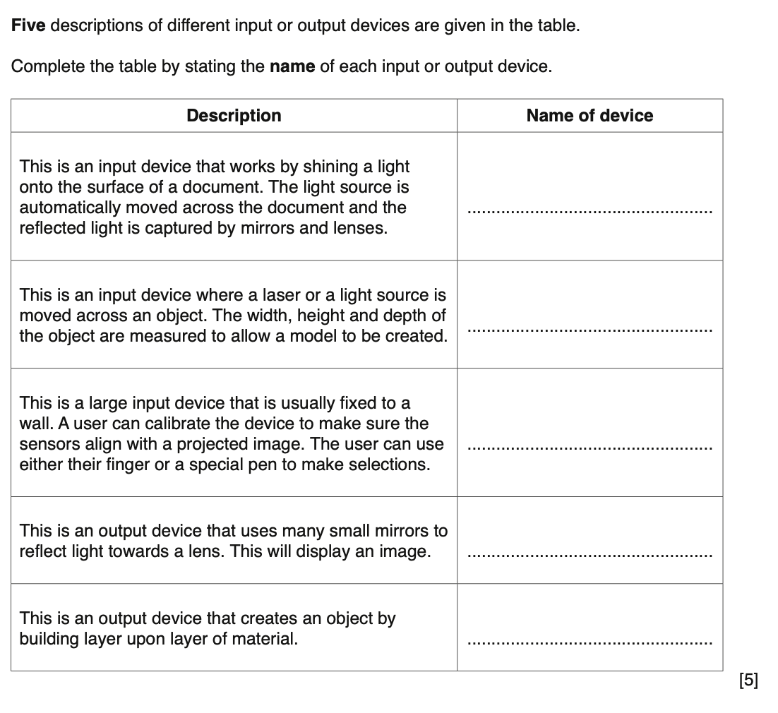

7)

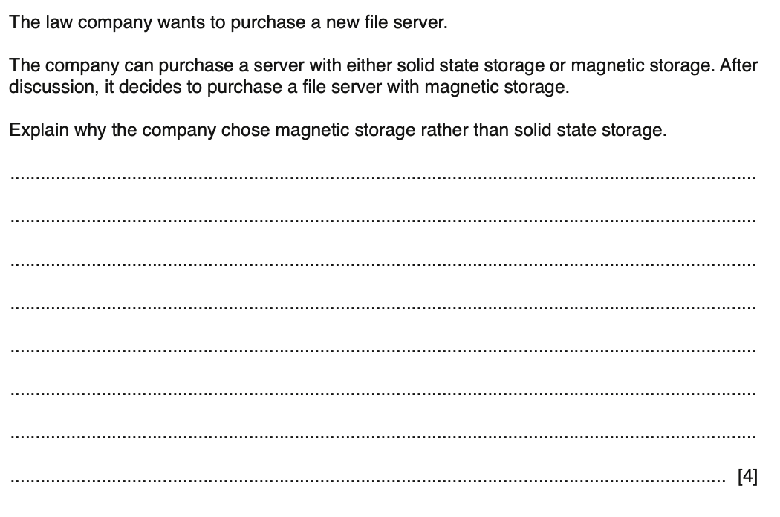

8)

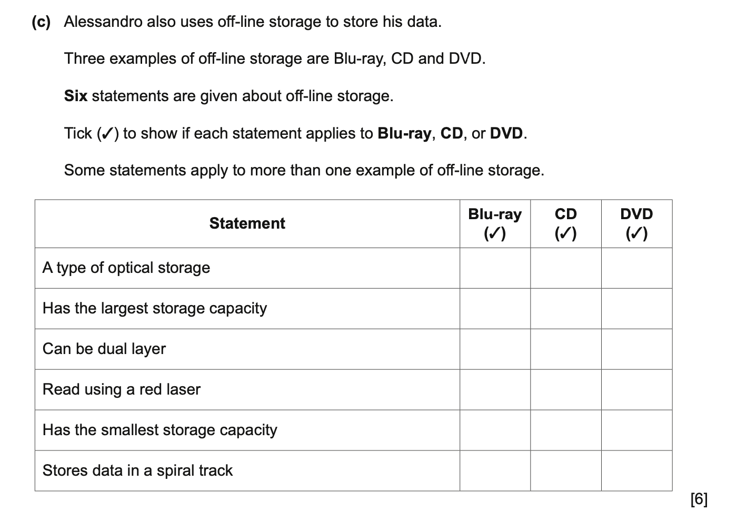

9)

