**Chapter 9 - Database MS**

Q1)

Q2)

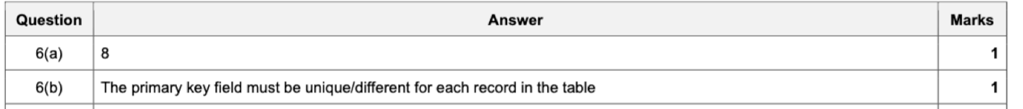

C)

SELECT GameID, GameName, GamePrice

FROM GAMES

WHERE NumberStock = 0

AND OnOrder = True

OREDER BY GameName ASC

Q3

c)

SELECT SubjectCode, SubjectName, Candidates

FROM ASSESS

WHERE Candidates < 150

ORDER BY Candidates desc

C)

SELECT COUNT(Quantity)

FROM AUDIOPARTS

WHERE Cost >=100.00