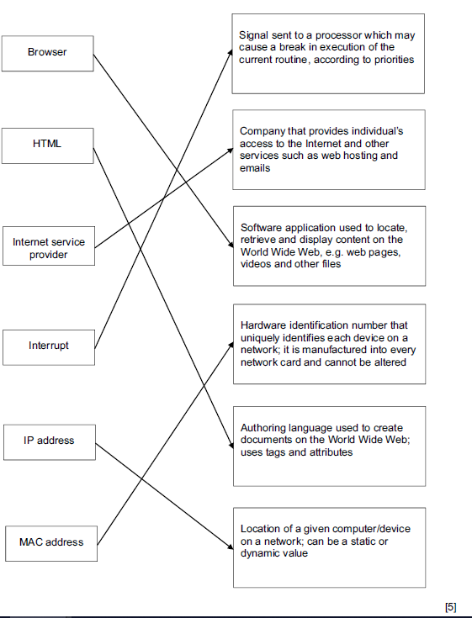

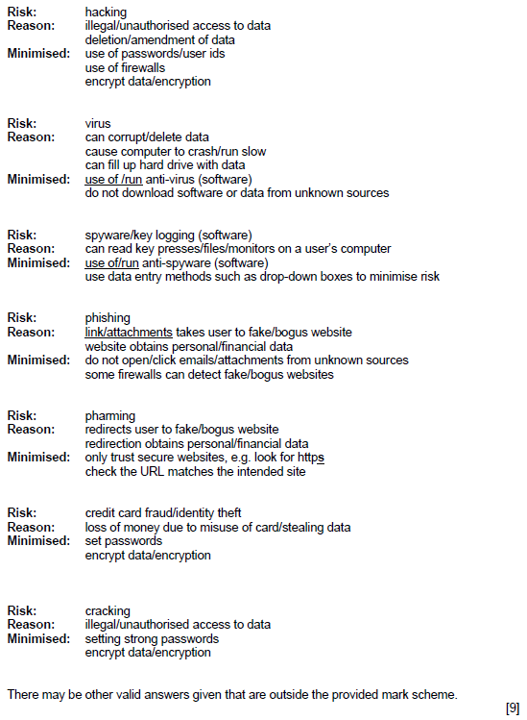

3)

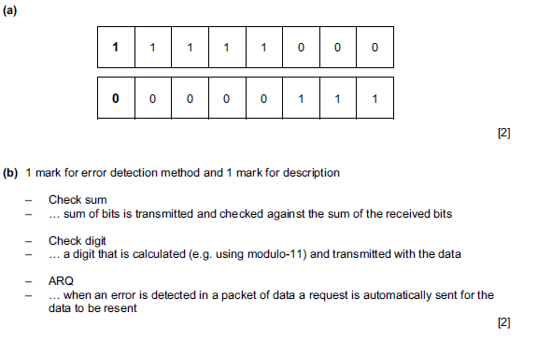

4)

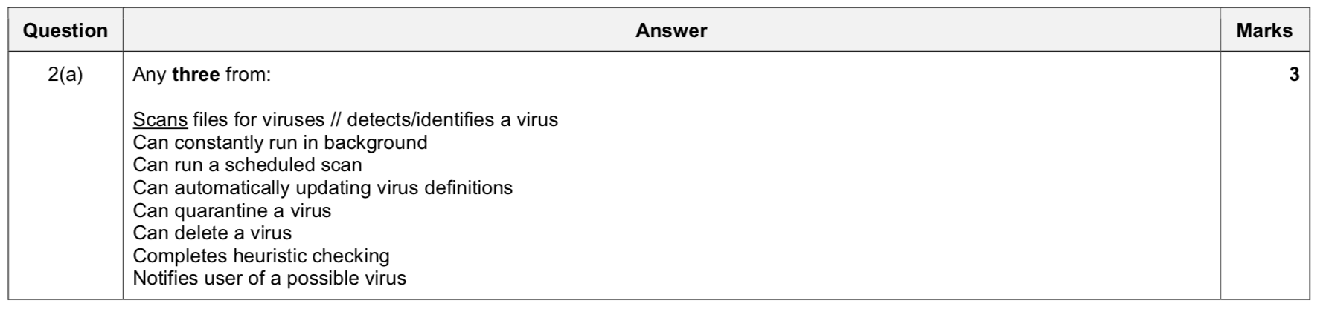

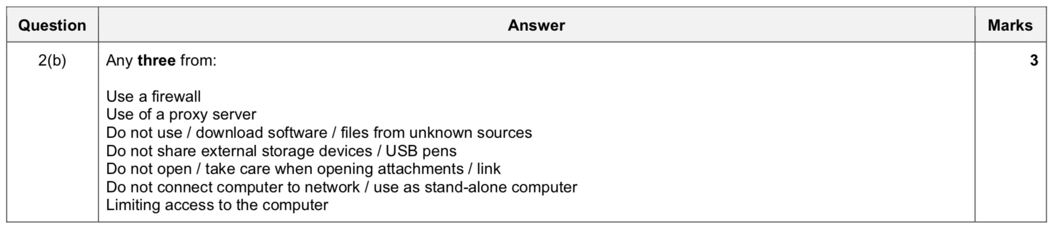

5)

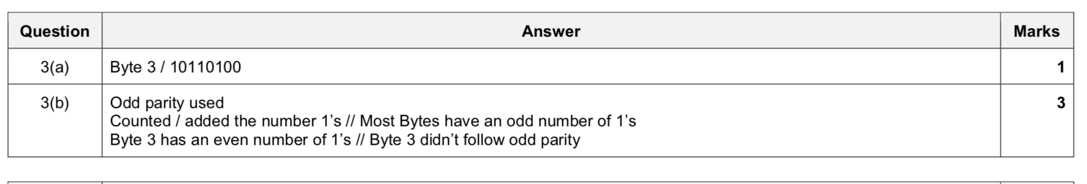

6)

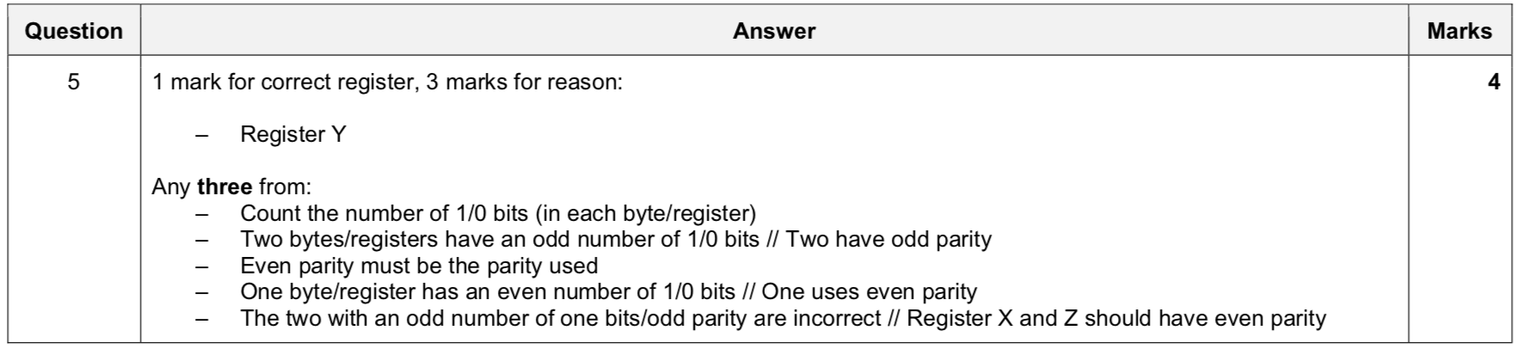

7) 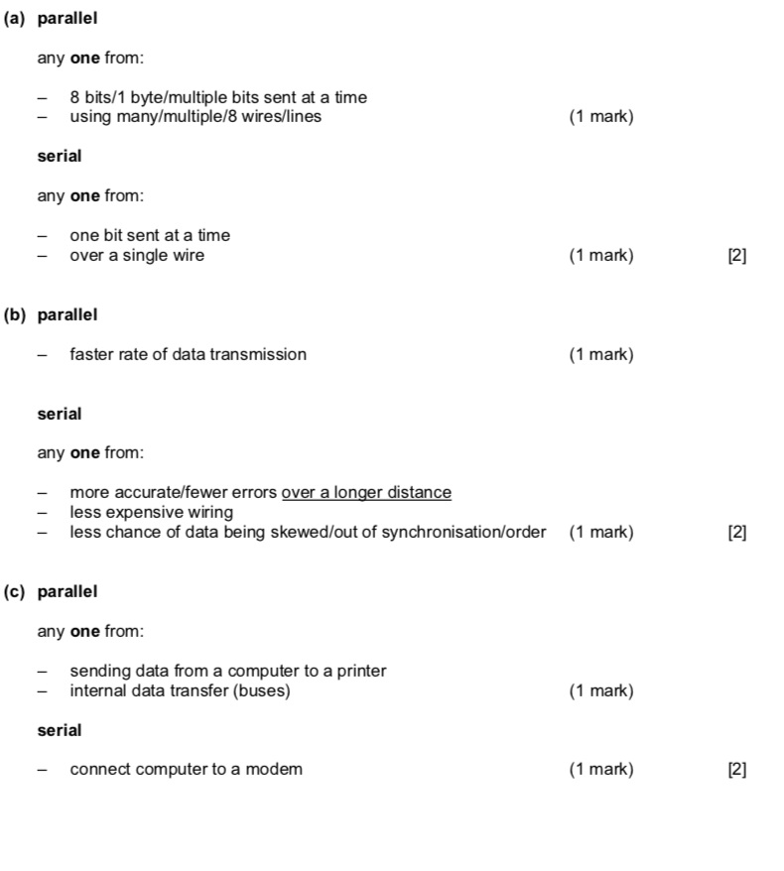

8)

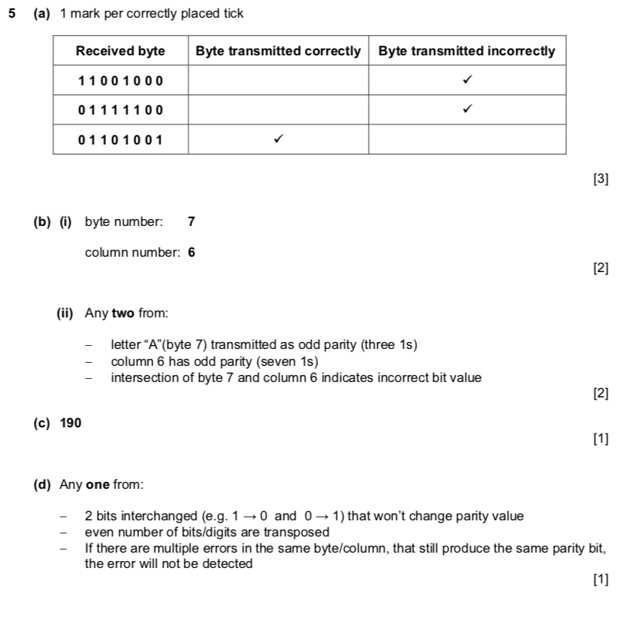

9)

Hacker - A person who tries to gain unauthorised access to a computer or network

Malware - A software program that is designed to damage or disrupt a computer

Virus - A software program that is designed to corrupt a computer and the files on it

Spyware - A software program that collects user information through their internet connection

10) Static