IGCSE Computer Science /26

Name: _________________

Chapter 9 Test: Databases

Q1

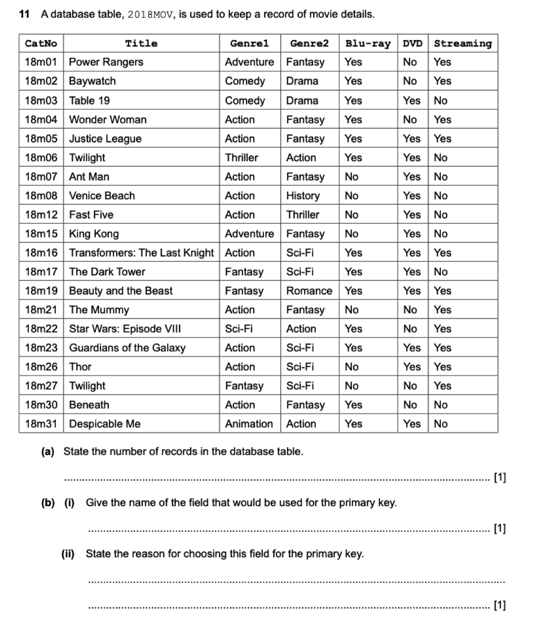

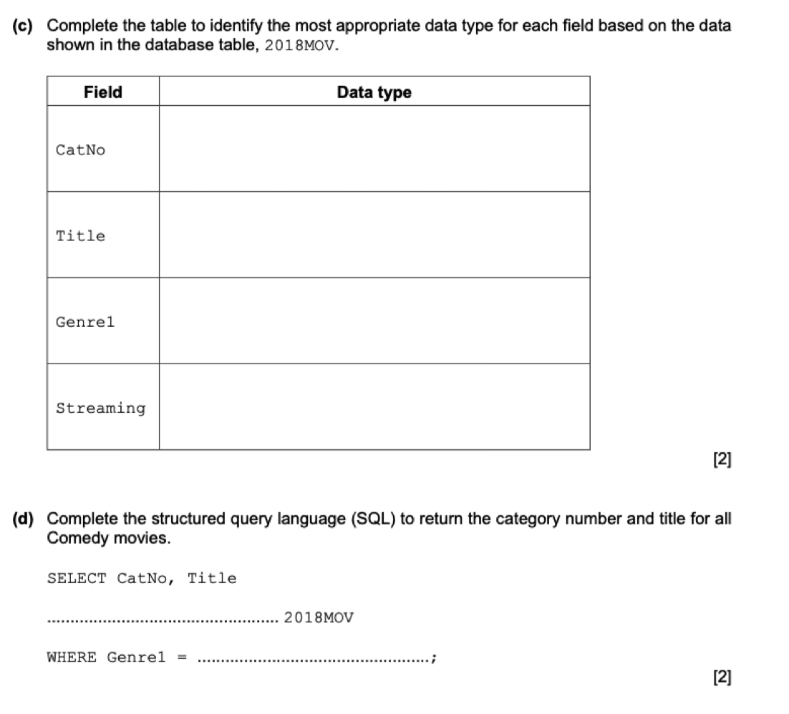
_{Q2}
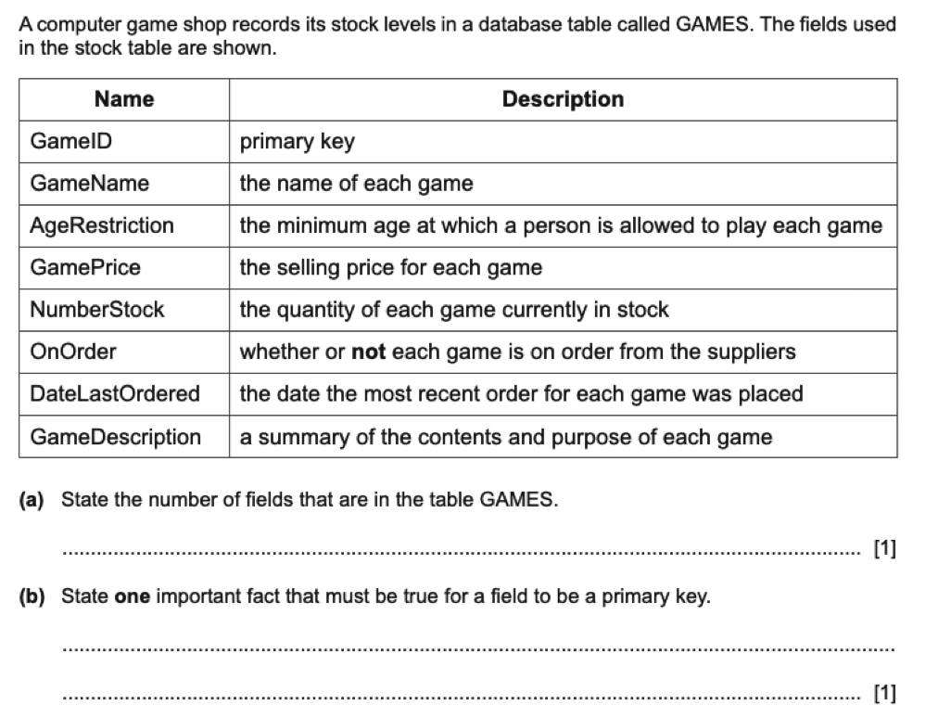

C) Write out the SQL to putput all games that have no stock that are on order from the suppliers. Select the following fields GameID, GameName, GamePrice ordered by the name of the game in ascending order, A-Z.

……………………………………………………………………………………………………………………………………………………………….
……………………………………………………………………………………………………………………………………………………………….
……………………………………………………………………………………………………………………………………………………………….
……………………………………………………………………………………………………………………………………………………………….
……………………………………………………………………………………………………………………………………………………………….
……………………………………………………………………………………………………………………………………………………………….
…………………………………………………………………………………………………………………………………………………………[3]

_{Q3)}
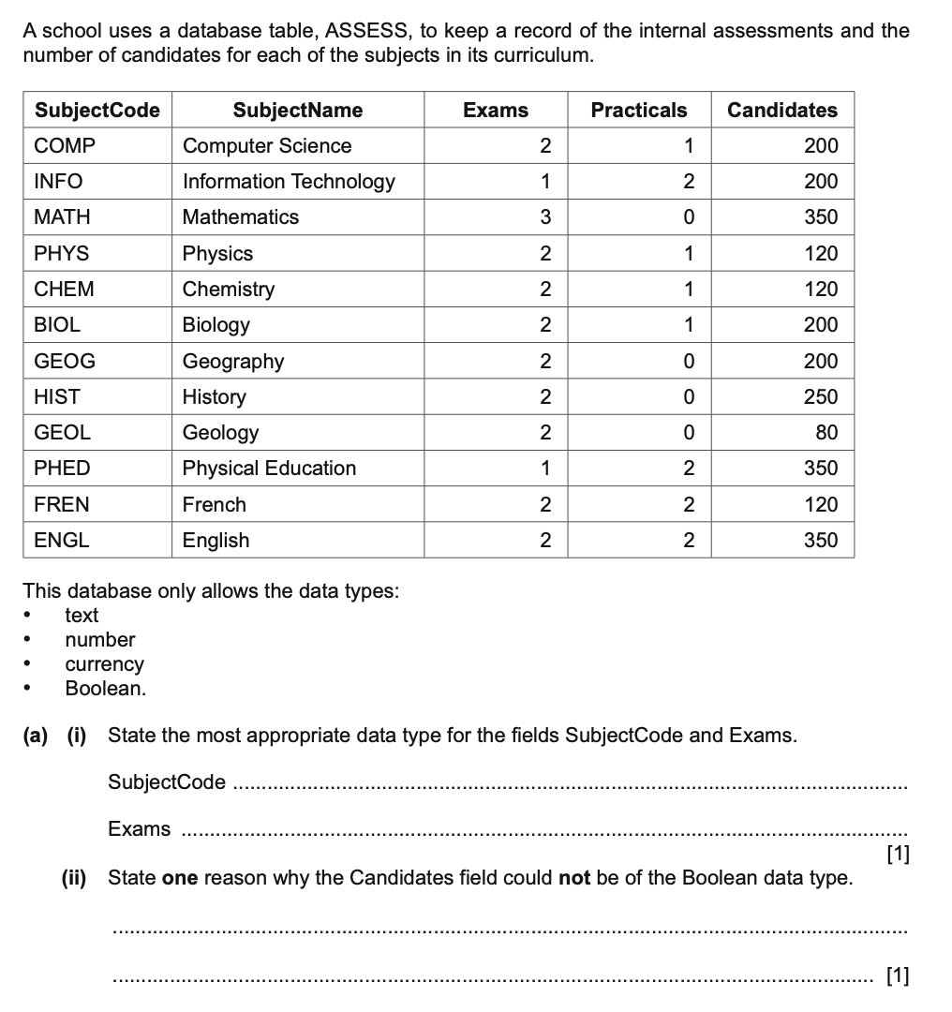

b). Show the output of the following SQL statement:

_{SELECT SubjectName, Candidates}
_{FROM ASSESS}
_{WHERE Practicals <1}
……………………………………………………………………………………………………………………………………………………………….
……………………………………………………………………………………………………………………………………………………………….
……………………………………………………………………………………………………………………………………………………………….
……………………………………………………………………………………………………………………………………………………………….
……………………………………………………………………………………………………………………………………………………………….
……………………………………………………………………………………………………………………………………………………………….
………………………………………………………………………………………………………………………………………………………… [ 3]

C) Write out the SQL to output the subjects with fewer than 150 candidates. Display only the SubjectCode, SubjectName and Candidates fields in order of the number of candidates from largest to smallest.

……………………………………………………………………………………………………………………………………………………………….
……………………………………………………………………………………………………………………………………………………………….
……………………………………………………………………………………………………………………………………………………………….
……………………………………………………………………………………………………………………………………………………………….
……………………………………………………………………………………………………………………………………………………………….
……………………………………………………………………………………………………………………………………………………………….
………………………………………………………………………………………………………………………………………………………… [ 3]

_{Q4}
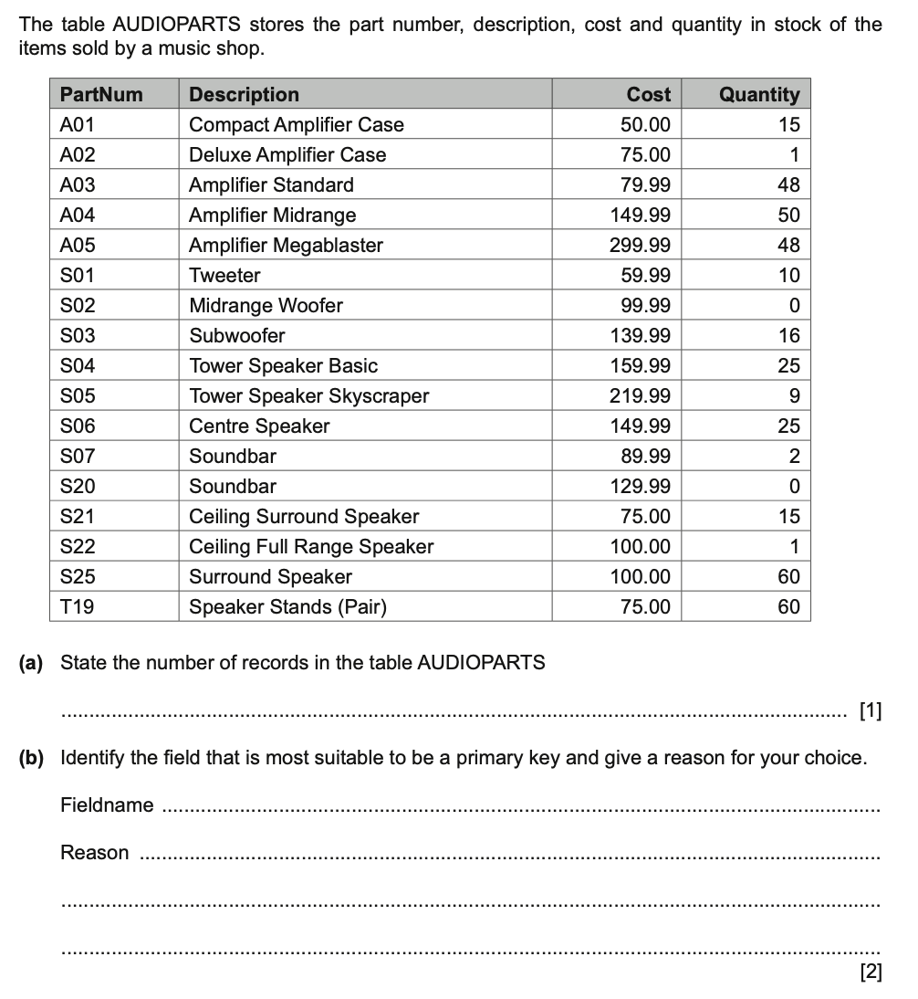
C) Write out the SQL statement to count the total quantity of parts that cost £100.00 or more
……………………………………………………………………………………………………………………………………………………………….
……………………………………………………………………………………………………………………………………………………………….
……………………………………………………………………………………………………………………………………………………………….
……………………………………………………………………………………………………………………………………………………………….
……………………………………………………………………………………………………………………………………………………………….
……………………………………………………………………………………………………………………………………………………………….
………………………………………………………………………………………………………………………………………………………… [ 3]

_{END OF TEST}

