**IGCSE Computer Science. /60**

**Name: _________________**

**Chapter 6 Test – New and Emerging Technology**

**1.**

**__________________________________________________**

**__________________________________________________**

**__________________________________________________**

**__________________________________________________**

**__________________________________________________**

**__________________________________________________**

**__________________________________________________**

**__________________________________________________**

**__________________________________________________**

**__________________________________________________**

**__________________________________________________**

**__________________________________________________**

**__________________________________________________**

**__________________________________________________**

**__________________________________________________**

**__________________________________________________**

**2.**

**A laboratory experiment involves the use of a burette ‘A’ adding acid to a solution in a conical flask ‘B’. As the reaction proceeds, the colour of the solution changes from yellow to red. The colour change is picked up by a sensor called a colorimeter. The amount of acid to be added is measured using two level detectors; the opening and closing of the burette tap is controlled by an actuator. As soon as the solution in ‘B’ turns red, the whole process is stopped. A microprocessor controls the whole process, as shown in the diagram.**

**a)  Explain how sensors, actuators and a microprocessor are used to control the experiment to ensure the final product (red colour) is always produced.**

__________________________________________________

__________________________________________________

__________________________________________________

__________________________________________________

__________________________________________________

__________________________________________________

__________________________________________________

__________________________________________________

[4]

**b)  Describe the advantages and disadvantages of using an automated system in this experiment.**

__________________________________________________

__________________________________________________

__________________________________________________

__________________________________________________

__________________________________________________

__________________________________________________

__________________________________________________

__________________________________________________

[4]

**3**

**a)  Name suitable sensors for each of the following automated systems.**

1. **Manufacture of a new vaccine which requires the mixing of four liquids in the ratio 1:2:3:4 as a single batch. The four liquids must be totally mixed and the temperature must be maintained at 35 °C (± 1 °C) which is a critical temperature.**
2. **A lighting display has been set up in one room of an art gallery. A random sequence of different coloured lights is under microprocessor control. The display in the room only switches on when visitors walk into the room; at the same time, the room lights are also dimmed to give the most dramatic effect of the light display.**

**__________________________________________________**

1. **A train uses automatic twin-doors. Both doors open automatically when the train stops. Both doors close again when no one is still boarding or leaving the train. The doors have a safety mechanism so that a passenger cannot become trapped between the two closing doors. The train can only move off when every door on the train has been safely closed.**

**[6]**

**b)  For each application in part a), give one advantage and one disadvantage of using automated systems. [4]**

**i)**

__________________________________________________

__________________________________________________

**ii)**

__________________________________________________

__________________________________________________

**iii)**

__________________________________________________

__________________________________________________

**4**

**The eight statements on the left-hand side of the table are either true or false. Tick (✓) the appropriate box to indicate which statements are true and which statements are false.**

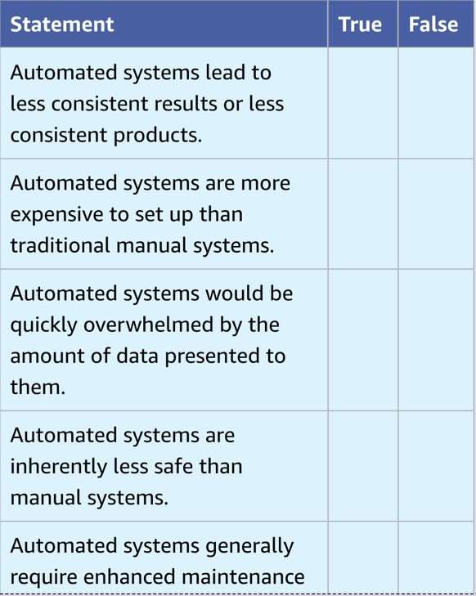

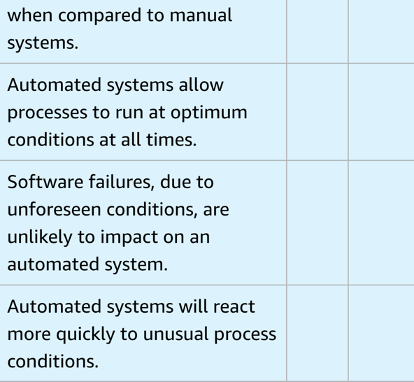

**[8]**

**5.**

**a)  Describe the three characteristics that must be shown by a device for it to be regarded as a robot. [3]**

__________________________________________________

__________________________________________________

__________________________________________________

__________________________________________________

__________________________________________________

**b)  Explain the difference between dependent and independent robots. [2]**

__________________________________________________

__________________________________________________

__________________________________________________

**c)  Describe briefly two examples of software robots. [2]**

__________________________________________________

__________________________________________________

**6**

**Use the following words to complete the paragraph that follows. [4]**

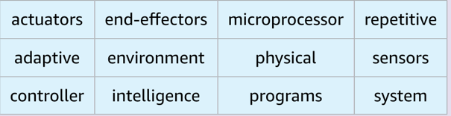

Robots can collect data from their surroundings by using ‹ ……………. ›. The data is then sent to a ‹ …………………… › to allow the robot to build up an image of its ‹ ………………….. ›. Robots can do various tasks by using different ‹ ……………………. ›. The ‘brain’ of the robot is often called a ‹ …………………… ›, which contains ‹ ……………………… › to allow it carry out various tasks automatically. Many robots are not (artificially) intelligent, since they only do ‹ ………………………. › tasks rather than requiring ‹ ……………….. › human characteristics. [4]

**7**

**Autonomous robots are used in space exploration and in undersea exploration. These robots have to either work in the near vacuum of space or the very high pressures under the oceans. They need to be equipped with many sensors and cameras to carry out their remote tasks.**

**a)  The undersea robots are being used to investigate shipwrecks. Describe how the sensors and cameras could be used to photograph the shipwrecks. Also describe the role of the microprocessor and actuators in taking photographs and any samples needed from the shipwreck for further investigation. [3]**

__________________________________________________

__________________________________________________

__________________________________________________

__________________________________________________

__________________________________________________

__________________________________________________

**b)  A space exploration robot has been sent on a mission to Mars. The robot needs to move around the surface of the planet safely, taking photographs and taking soil/rock samples for later analysis.**

**i)   Describe how sensors, actuators and a microprocessor can be used to take samples from the planet’s surface. [2]**

__________________________________________________

__________________________________________________

__________________________________________________

__________________________________________________

**ii)  Describe three uses of the cameras on this autonomous robot. [3]**

__________________________________________________

__________________________________________________

__________________________________________________

__________________________________________________

**c)  Describe the advantages of using autonomous robots in both undersea and outer space exploration. [3]**

__________________________________________________

__________________________________________________

__________________________________________________

**d)  Give two other examples of where autonomous robots could be used. [2]**

__________________________________________________

__________________________________________________

__________________________________________________

**End of test**